High Fidelity Wireframes Prototype

Fervor – The Dating App

Screen 1: Login Screen of the application.

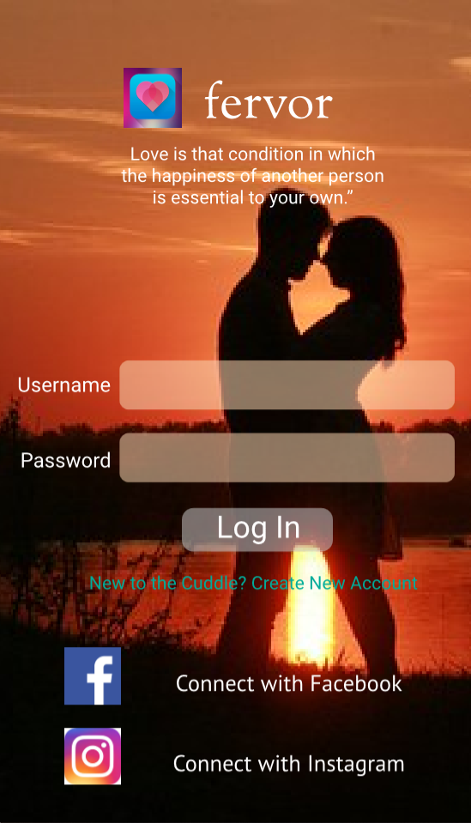

Screen 2: Creating profile in Fervor. Screen 3: Answering the question 1.

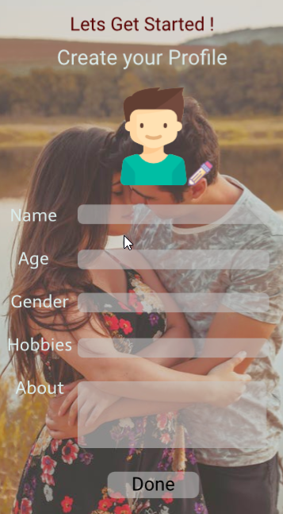 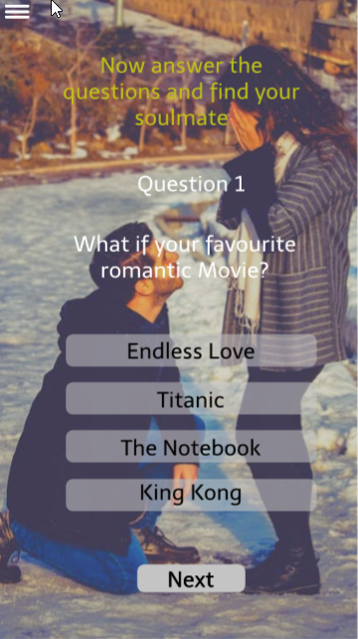

Screen 4: Answering the question 2. Screen 5: Answering the question 3.

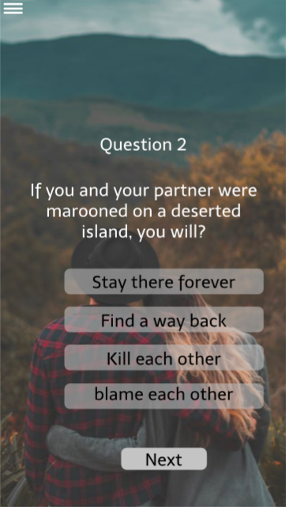 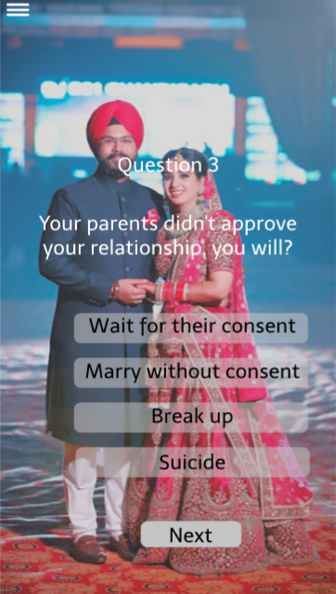

Screen 6: Answering the question 4. Screen 7: Answering the final question and done.

 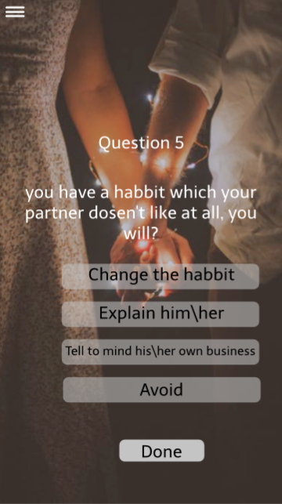

Screen 8: Answers submitted and launching Search. Screen 9: Search Results

 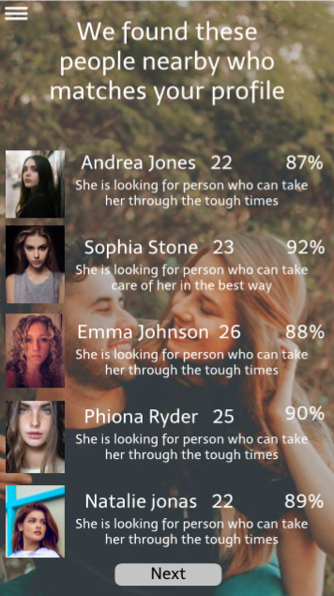

Screen 10: Visiting a Profile and sending a request. Screen 11: After acceptance, chat window.

